Payeer for CMS Drupal 7 (Commerce Kickstart2)

Go to the admin panel and open the menu “Site settings -> Modules”.

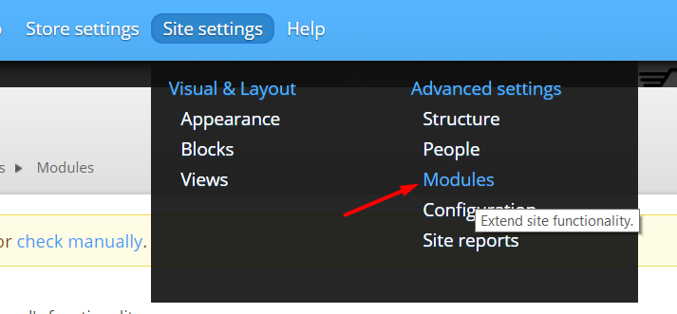

Press the button “Install new module”.

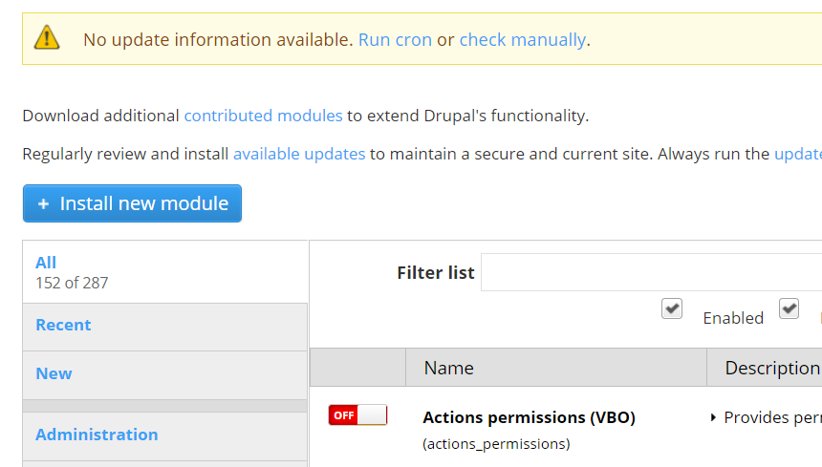

Select from the files module.zip and click “Install”.

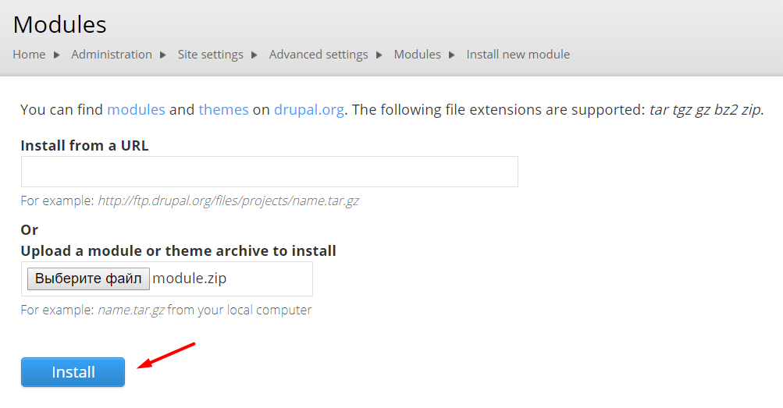

After confirming a successful installation, click “Administratiоn pagеs”.

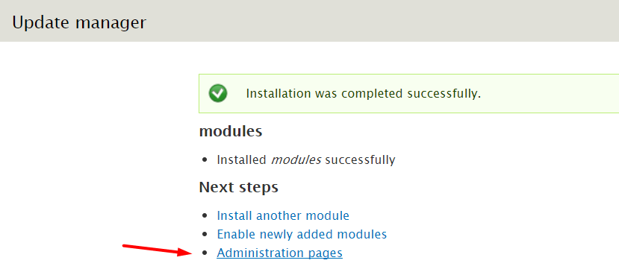

Again, go to the list of all modules “Site settings -> Modules”.

Locate the module Payeer and turn it on. Press “Save configuration”.

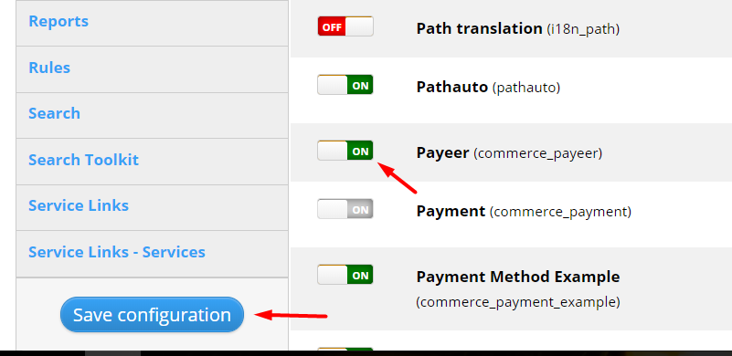

Open the menu “Store settings -> Payment methods”.
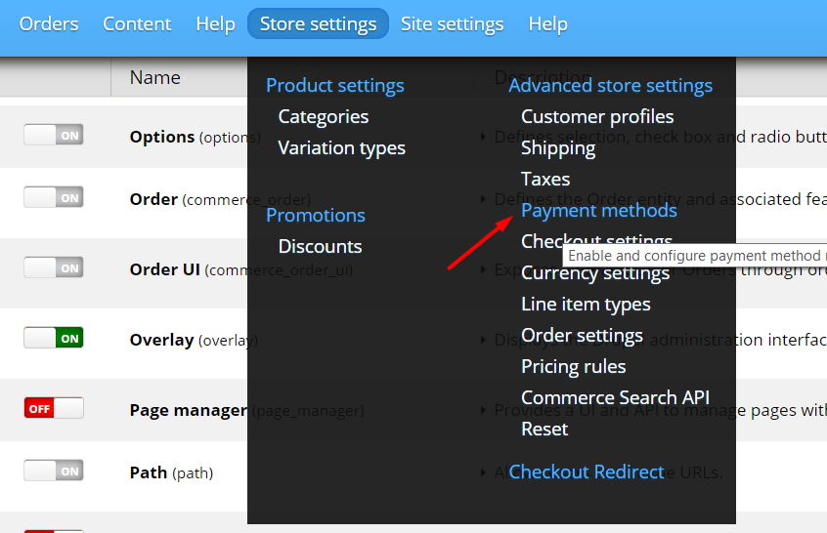

Payееr should appear in the list of available payment methods.

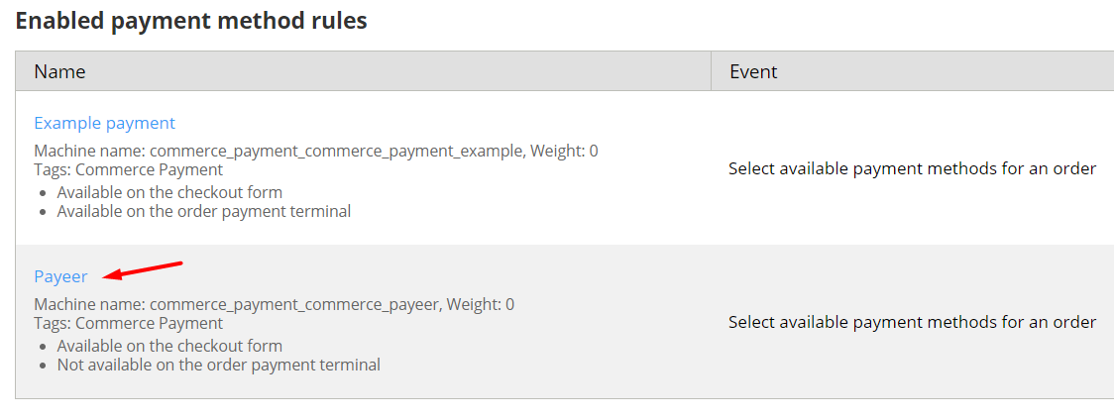
Open Payееr. Press on “Enable payment method: Payeer”.
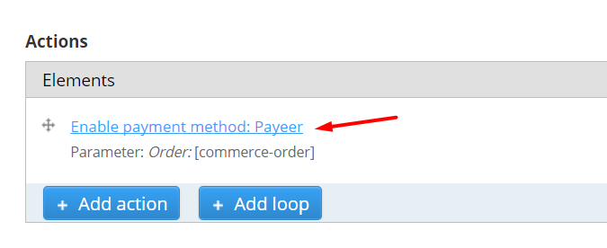
Enter the parameters to set up the payment module:
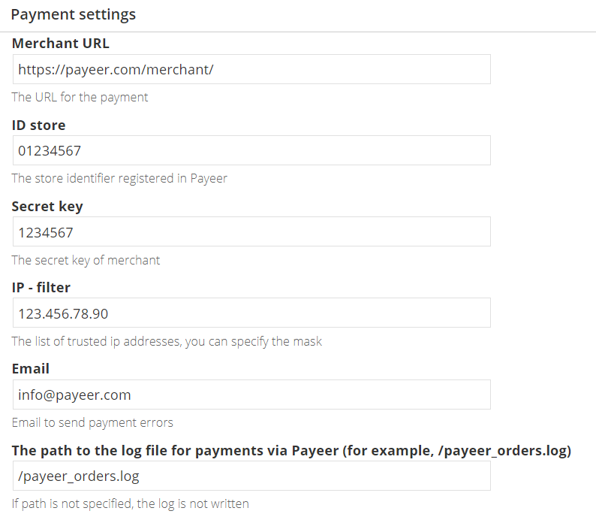
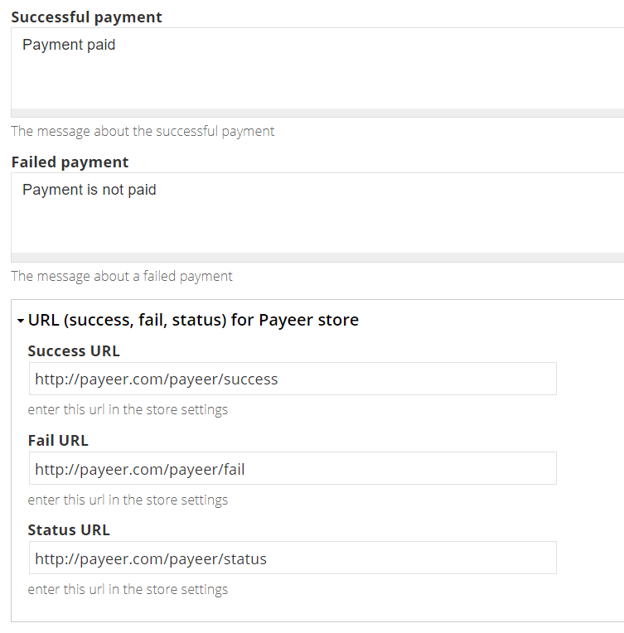
Merchant URL: the default path to the payment https://payeer.com/merchant/
Merchant ID: id of your store in the system Payeer.com (can be found in the personal cabinet).
Secret key: the secret key of your store, also issued to you when registering in the system.
The path to the log file: if you specify the path to the file logging, you will be recording information about payments via Payeer.
IP filter: You can specify the list of all trusted ip addresses of servers, separated by commas. You can also specify a mask instead of the ip address. If the field is empty, checking for trusted ip addresses is not performed.
For example:
192.168.71.87, 192.165.83.17, 192.178.34.15
Or 192.*.71.87, 192.165.83.*, 192.*.34.15
Or *.*.*.* - all available ip addresses

Email for warning send: enter your email address to receive notices in the event of an error of payment. The letter will state the reason and basic information about the payment.
Enter a message in case of successful payment, failed payment.
Press «Save».
Then on the website payeer.com in the dashboard, enter the URL in the store settings. Data URLS can be found and copied in the module settings Payeer.

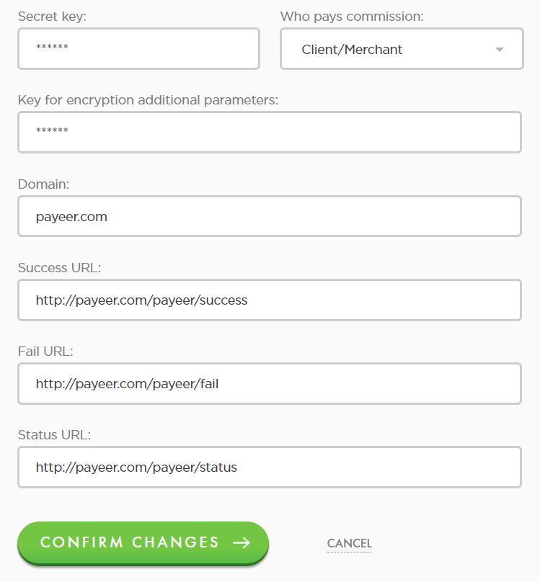
Success URL
http://*****/payeer/success
Fail URL
http://*****/payeer/fail
Status URL
http://*****/payeer/status
Where ***** is your domain.
Confirm changes.
Module Payeer for CMS Drupal 7 (Commerce Kickstart2) configured.

